**Summary Of Chapter 4**

**What Is Organising**

Organising is a “process of defining the essential relationships among people, tasks and activities in such a way that all the organisation’s resources are integrated and coordinated to accomplish its objectives efficiently and effectively”. — Pearce and Robinson

**Purpose Of Organising**

* Divides work to be done into specific jobs and departments.
* Assigns tasks and responsibilities associated with individual jobs.
* Coordinates diverse organisational tasks.

**Organisational Structure**

An organizational structure is a system that outlines how certain activities are directed in order to achieve the goals of an organization. These activities can include rules, roles, and responsibilities. The organizational structure also determines how information flows between levels within the company.

**Work specialization**

Work Specialization, also known as division of labor, refers to the degree to which tasks necessary to achieve organizational objectives is divided into various jobs. Work specialization allow managers to break complex tasks into smaller, more precise tasks that individual employees can complete.

**Departmentalisation by Type**

* **Functional** 
  + Grouping jobs by functions performed
* **Product**
  + Grouping jobs by product line
* **Geographical**
  + Grouping jobs on the basis of territory or geography
* **Process** 
  + Grouping jobs on the basis of product or customer flow
* **Customer**
  + Grouping jobs by type of customer and needs

**Job.**

* + A collection of tasks performed in support of organisational objectives.

**Job design.**

* + The process of creating or defining jobs by assigning specific work tasks to individuals and groups.

**Job simplification.**

* + Standardising work procedures and employing people in well-defined and highly specialised tasks.

**Job rotation.**

Increases task variety by periodically shifting workers among jobs involving different task assignments.

**Job enlargement.**

Increases task variety by combining two or more tasks previously assigned to separate workers.

**Horizontal loading.**

 The practice of adding extra tasks that need a similar level of skill to an existing job.

**Job enrichment**

is a common motivational technique used by organizations to give an employee greater satisfaction in his work. It means giving an employee additional responsibilities previously reserved for his manager or other higher-ranking positions.

**Chain of Command**

In an organizational structure, “chain of command” refers to a company's hierarchy of reporting relationships – from the bottom to the top of an organization, who must answer to whom. The chain of command not only establishes accountability, it lays out a company's lines of authority and decision-making power.

**Span of Control**

Span of control refers to the number of subordinates under the manager's direct control. As an example, a manager with five direct reports has a span of control of five.

**Flat and Tall Organisation**

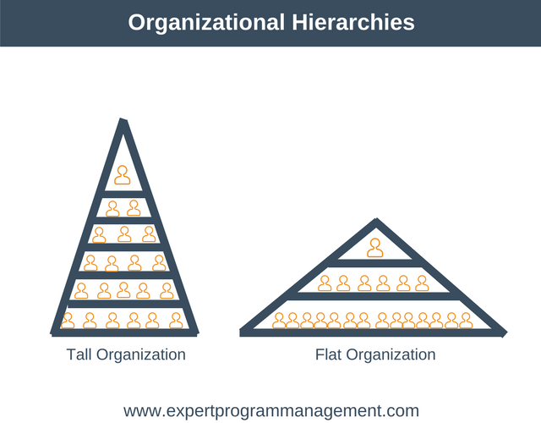

**Tall Organization**

A tall organizational structure means that management is broken down into several layers, with executives on top and normal employees on the bottom. A top-down structure is another way to refer to a tall organizational structure.

**Flat Organization**

A flat organization refers to an organization structure with few or no levels of management between management and staff level employees. The flat organization supervises employees less while promoting their increased involvement in the decision-making process.

**Centralisation**

The degree to which decision-making is concentrated at a single point in the organizations.

**Decentralisation**

Organisations in which decision-making is pushed down to the managers who are closest to the action.

**Employee Empowerment**

Increasing the decision-making authority (power) of employees.

**Formalisation**

The degree to which jobs within the organisation are standardised and the extent to which employee behavior is guided by rules and procedures.